**Lab Session 03**

**Exercise a:**

**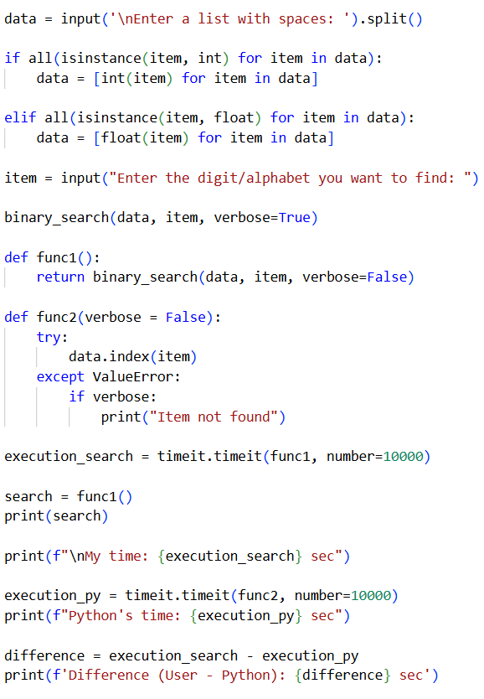CODE**

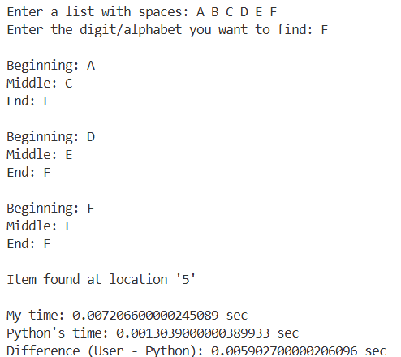**OUTPUT**

**Exercise c:**

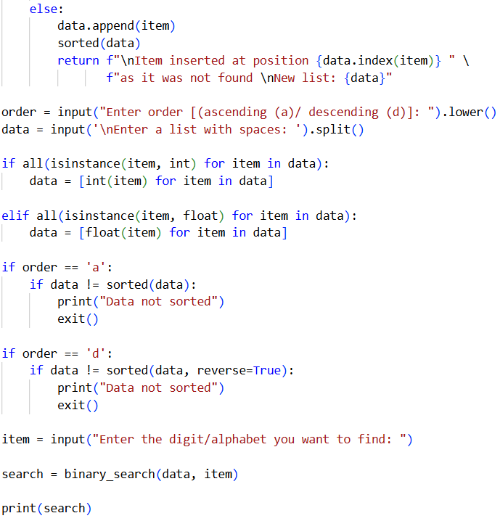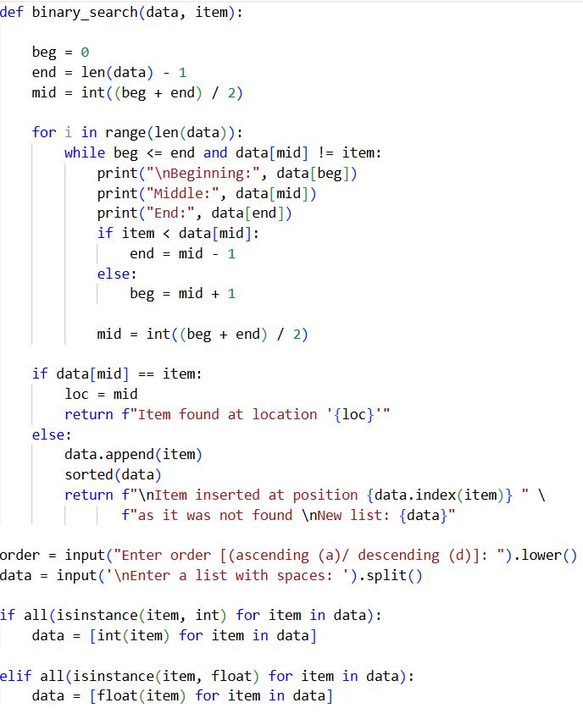**CODE**

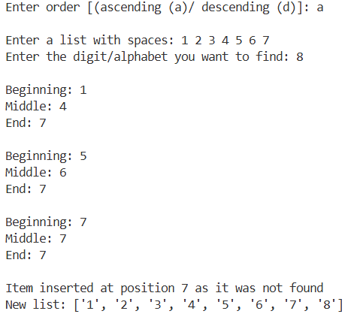**OUTPUT**

